UDC 81’33

G.Zh. Smagulova
Karaganda Buketov National Research university
E-mail: xxxxxxx@gmail.com
ORCID: https://orcid.org/xxxx-xxxx-xxxx-xxxx
Scopus ID: xxxxxxxxxxxx

Emotional intelligence training intervention for decreasing

students’ foreign language speaking anxiety in a university setting

The paper addresses the problem of foreign language speaking anxiety (FLSA) as a psychological and emotional barrier that impairs oral participation and language development among university students. This study explores a novel approach by evaluating the efficacy of a non-integrated emotional intelligence (EI) training intervention aimed at improving students’ emotion regulation skills to decrease FLSA intensity and increase willingness to communicate (WTC). Utilizing a quasi-experimental pre-test-intervention-post-test design, first-year undergraduate students ($N = 22$) from an Interpretation Department were divided into an experimental group ($n = 10$) and a control group ($n = 12$). The experimental group participated in an eight-session training program introducing specific EI techniques-including mindful breathing, debriefing sheets, goal-setting and others conducted outside regular language classes. Quantitative data were gathered using the Foreign Language Classroom Anxiety Scale (FLCAS), the Emotion Regulation Skills Questionnaire (ERSQ-27), and an adapted WTC scale, and analyzed via paired-samples t-tests. The statistical results demonstrated significant improvements within the experimental group: speaking anxiety substantially decreased ($p = .009$), emotion regulation skills increased ($p = .009$), and WTC rose significantly ($p = .007$).
Keywords: foreign language speaking anxiety, emotional intelligence, emotion regulation, willingness to communicate, standalone intervention, cognitive reappraisal.

Introduction
The phenomenon of anxiety within the educational context has been extensively studied since the mid-twentieth century, particularly in relation to foreign language acquisition. Anxiety that occurs inside the foreign language classroom is formally conceptualized as foreign language anxiety (FLA), a term popularized by Horwitz and colleagues. Empirical research indicates that anxiety, especially when experienced at a high degree, significantly reduces students' receptiveness to new information and actively interferes with the process of acquiring novel skills and knowledge [1, 2].
Methods and Materials
The study employed a quasi-experimental research design involving an experimental group ($n = 10$) and a control group ($n = 12$) composed of first-year undergraduate students from an Interpretation Department. Convenience sampling was utilized due to institutional arrangements and availability through the academic advisor.
Results and Discussion
Quantitative pre-test and post-test data were systematically entered and verified. Statistical differences within each group over time were calculated using a paired-samples t-test, which was selected because the same participants were measured repeatedly across two temporal stages. To supplement the numerical data, a semi-structured qualitative interview was conducted with the foreign language teacher of the experimental group to evaluate observable changes in real classroom interactions
At the initial pre-test stage, both the experimental and control groups exhibited highly similar baselines across all primary variables. Both cohorts demonstrated elevated levels of speaking anxiety alongside moderate emotion regulation skills and communicative willingness.
At the initial pre-test stage, both the experimental and control groups exhibited highly similar baselines across all primary variables. Both cohorts demonstrated elevated levels of speaking anxiety alongside moderate emotion regulation skills and communicative willingness.
Following the completion of the eight-session intervention program, distinct statistical patterns emerged between the experimental and control groups. The exact statistical breakdowns, including means ($M$), standard deviations ($SD$), t-values ($t$), degrees of freedom ($df$), and significance levels ($p$), are presented in Table 1.

Table 1
Comparative Statistical Analysis of Pre-test and Post-test Performance

Group | Variable | Pre-test M (SD) | Post-test M (SD) | t(df) | p
Control Group | FLSA | 91.42 (17.70) | 86.58 (16.67) | 2.19 (11) | .051
Control Group | EI / ERSQ-27 | 67.42 (12.09) | 68.67 (11.41) | -0.54 (11) | .601
Control Group | WTC | 61.42 (17.15) | 65.50 (15.76) | -0.69 (11) | .507
Experimental Group | FLSA | 96.10 (21.49) | 86.90 (15.91) | 3.29 (9) | .009
Experimental Group | EI / ERSQ-27 | 62.60 (13.84) | 68.40 (12.46) | -3.35 (9) | .009

The paired-samples t-test confirmed that the experimental group achieved statistically significant improvements across all tested dimensions. Specifically, FLSA decreased significantly from 96.10 to 86.90, $t(9) = 3.29, p = .009$. Concurrently, emotion regulation scores increased significantly from 62.60 to 68.40, $t(9) = -3.35, p = .009$, and WTC scores rose significantly from 61.90 to 69.60, $t(9) = -3.44, p = .007$.
Conversely, the control group showed no statistically significant modifications. The reduction in FLSA within the control cohort was marginal and failed to satisfy standard significance boundaries ($p = .051$). Changes in EI ($p = .601$) and WTC ($p = .507$) for the control group were highly non-significant, demonstrating that standard language instruction alone did not systematically enhance emotional skills or willingness to speak during this timeframe.
The dynamic shift and visual trajectory of the quantitative benchmarks achieved by the experimental cohort across all three tested parameters are illustrated in detail below (see Fig. 1). The color-coded parameters distinctly reflect the systematic boundaries between baseline anxiety levels and the subsequent development of communicative readiness.
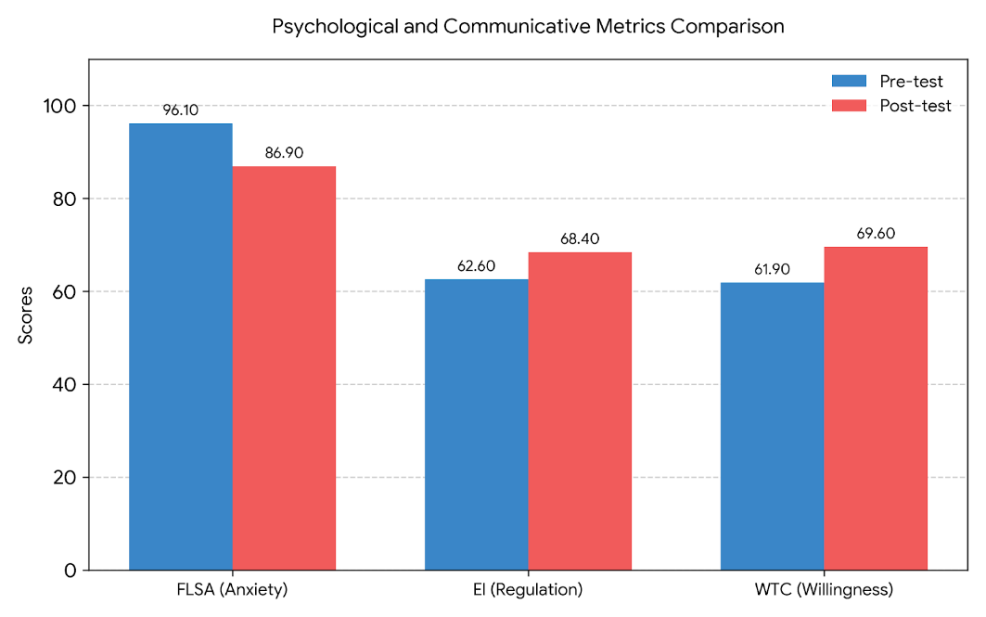
Figure 1. Comparative dynamics of psychological and communicative benchmarks
in the experimental group pre- and post-EI intervention
Conclusions
The given research demonstrated that foreign language speaking anxiety is a multidimensional emotional barrier that cannot be resolved through purely linguistic methods. By establishing a clear emotional training model, this study proved that explicit instruction in emotional intelligence significantly improves emotion regulation skills, reduces situation-specific oral anxiety, and directly enhances learners' behavioral willingness to communicate. Equipped with mindful breathing, cognitive reappraisal tools, and structured self-reflection strategies, students transitioned from passive avoidance to active communication. Ultimately, addressing the emotional architecture of the learner is not a secondary concern, but an indispensable foundation for successful communicative language education.
Acknowledgements
The study was carried out under the project “XXXXXXXXXXXXXX”.
CRediT Author Statement
The author confirms being the sole creator of this work and bears full responsibility for its content.
Conflict of Interest Statement
The author declares that she has no known competing financial interests or personal relationships that could have appeared to influence the work reported in this paper.

References
- Horwitz, E. K., Horwitz, M. B., & Cope, J. (1986). Foreign language classroom anxiety. The Modern Language Journal, 70(2), 125-132. https://doi.org/10.1111/j.1540-4781.1986.tb05256.x
- MacIntyre, P. D., & Gardner, R. C. (1991). Methods and results in the study of foreign language anxiety: A review of the literature. Language Learning, 41(1), 85-117. https://doi.org/10.1111/j.1467-1770.1991.tb00675.x
- Mayer, J. D., & Salovey, P. (1997). What is emotional intelligence? In P. Salovey & D. Sluyter (Eds.), Emotional development and emotional intelligence: Educational implications (pp. 3-31). Basic Books.
- Gross, J. J. (1998). The emerging field of emotion regulation: An integrative review. Review of General Psychology, 2(3), 271-299. https://doi.org/10.1037/1089-2680.2.3.271
- MacIntyre, P. D., Dörnyei, Z., Clément, R., & Noels, K. A. (1998). Conceptualizing willingness to communicate in a L2: A situational model of L2 confidence and affiliation. The Modern Language Journal, 82(4), 545-562. https://doi.org/10.1111/j.1540-4781.1998.tb05543.x
- Eysenck, M. W., Derakshan, N., Santos, R., & Calvo, M. G. (2007). Anxiety and cognitive performance: Attentional control theory. Emotion, 7(2), 336-353. https://doi.org/10.1037/1528-3542.7.2.336
- Spielberger, C. D. (2010). State-Trait Anxiety Inventory. Wiley LCC. https://doi.org/10.1002/9780470479216.corpsy0943

Information about the author
Smagulova G. Zh. - PhD, Associate Professor, Karaganda Buketov National University, Foreign Languages Faculty, Translation Theory and Practice Department; e-mail: xxxxxxxx@gmail.com; ORCID ID: https://orcid.org/xxxx-xxxx-xxxx-xxxx; Scopus ID: xxxxxxxxxxx

